**Excelsior Multi Academy Trust**

**Anti-Bullying Policy**

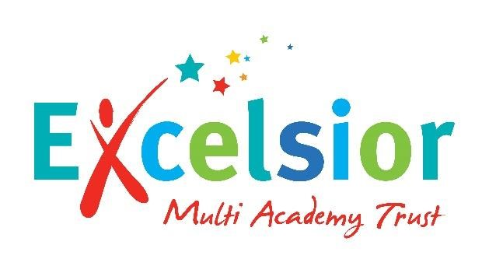

# Rights Respecting Schools’ Article/s

*A14: Every child has the right to think and believe what they want and to practise* *their religion, as long as they are not stopping other people from enjoying their rights.*

A29: *Education must develop every child’s personality, talents and abilities to the* *full. It must encourage the child’s respect for human rights, as well as respect for their parents, their own and other cultures and the environment.*

**Anti-Bullying Policy**

At Excelsior Multi-Academy Trust, we are committed to enabling all members of the school community to be safe and secure, both physically and emotionally; enabling all children to reach their academic potential.

Bullying of any kind is unacceptable in our school. We strive to maintain our anti-bullying ethos in which relationships are based on mutual respect, trust, caring and consideration for others. If bullying does occur, all pupils should feel empowered to tell someone and feel secure in the knowledge that incidents will be dealt with promptly and effectively.

**What is bullying?**

The Anti-Bullying Alliance (ABA) and its members have a shared definition of bullying based on research from across the world over the last 30 years. Excelsior Multi Academy Trust uses the ABA definition.

ABA defines bullying as:

“The repetitive, intentional hurting of one person or group by another person or group, where the relationship involves an imbalance of power. It can happen face to face or online.”

There are four key elements to this definition:

* hurtful
* repetition
* power imbalance
* intentional

Bullying behaviour can be:

* Physical – pushing, poking, kicking, hitting, biting, pinching etc.
* Verbal - name calling, sarcasm, spreading rumours, threats, teasing, belittling.
* Emotional – isolating others, tormenting, hiding books, threatening gestures, ridicule, humiliation, intimidating, excluding, manipulation and coercion.
* Sexual – unwanted physical contact, inappropriate touching, abusive comments, homophobic abuse, exposure to inappropriate films etc.
* Online /cyber – posting on social media, sharing photos, sending nasty text messages, social exclusion.
* Indirect - Can include the exploitation of individuals.

At Excelsior Multi Academy Trust, we differentiate between incidents where pupils are unpleasant or disrespectful to one another and bullying, which is the term we use for repeated, intentional, targeted behaviour intended to cause harm.

The school clearly communicates a whole-school commitment to addressing bullying which is regularly promoted across the whole school. At Excelsior Multi Academy Trust, we

intend to intervene early to resolve incidents of nastiness or disrespectful behaviour before the behaviour becomes repeated and therefore defined as bullying. This is central in our approach to preventing bullying.

We recognise the need not only to respond to and manage incidents of bullying effectively, but also to actively seek to **prevent** the occurrence of bullying. We aim to promote our 3 school rules of Ready, Respectful and Safe in relation to the constructive management of peer relationships and co-operative behaviours. We actively promote the safeguarding of children through our Personal Development curriculum and the school rules.

## Objectives of this policy

* All governors, teachers and support staff, pupils and parents should have a consistent, shared understanding of the school’s definition of bullying;
* All governors, teaching and support staff should know what the school policy is on bullying, and follow it when bullying is reported;
* All pupils and parents should know what the school policy is on bullying, and what they should do if bullying arises;
* As a school we take bullying seriously. Pupils and parents should be assured that they will be supported when bullying is reported;
* Bullying will not be tolerated.

Bullying can be fuelled by prejudice and, through the Personal Development curriculum at Excelsior Multi Academy Trust, we work to create a culture where prejudice and hatred is not accepted. This includes behaviour that is homophobic, transphobic, racist, targeted at faith, sexist and disablist.

Bullying thrives in cultures where name-calling, unwanted touch, rumour mongering and disrespect go unchallenged. Our behaviour policy sets clear boundaries and all staff are responsible for making sure they are understood by all pupils and the behaviour policy is followed consistently.

All reported instances of bullying will be investigated by a member of staff. Staff will encourage pupil cooperation and the development of interpersonal skills. All types of bullying will be discussed as part of the curriculum. Diversity, difference and respect for others is promoted and celebrated through the PD curriculum and in our daily assemblies. Seating plans and pupil groupings may be adapted to prevent instances of bullying.

All members of the school are made aware of this policy and their responsibilities in relation to it. All staff members receive annual training on identifying and dealing with the different types of bullying alongside behaviour and relationship training, including looking at the behaviour policy. The pastoral rooms in our schools are supervised by members of staff from our pastoral care team and are available for pupils to go to during free time if they feel threatened or wish to be alone. Staff will endeavour to build relationships that enable students to disclose concerns and seek help if they are being bullied.

## Signs and Symptoms

A child may indicate by signs or behaviour that he or she is a target of bullying behaviour. All school staff should be aware of these possible signs and that they should investigate if a child:

* is frightened of walking to and from school;
* is unwilling to go out at playtime or lunch time;
* is unhappy about coming to school;
* changes their usual routine;
* becomes withdrawn, anxious, or lacking in confidence;
* begins to do less well at school;
* has possessions which 'go missing';
* has unexplained cuts and bruises;
* becomes aggressive, disruptive or unreasonable (and this is a change from their normal behaviour);
* is using bullying behaviour towards other children or siblings;
* is frightened to say what is wrong;
* gives improbable excuses for any of the above.

Research undertaken by the DfE indicates that children are more likely to tell a family member that they are the target of bullying behaviour than tell their teacher. At Excelsior Multi Academy Trustwe encourage parents to report incidents of bullying behaviour immediately, so that appropriate action can be taken.

Parents may notice signs at home including a child:

* being unduly worried about being in school;
* crying themselves to sleep or has nightmares;
* often feeling ill in the morning or using delaying tactics to come to school; • coming home with clothes torn or possessions damaged;
* stopping eating.

These signs and behaviours could indicate other problems but being the target of bullying behaviour should be considered as a possibility and should be investigated.

## Procedures

The emphasis is on collective responsibility, referring to the behaviour policy.

Implementing the guidelines in the behaviour policy systematically and continuously will enable children to be Ready to learn, Respectful to all and Safe. We aim to create an ethos of openness, enabling the sharing of concerns amongst staff, children and parents.

If bullying behaviour is suspected or has been reported:

* Class teachers will liaise with colleagues, including but not limited to the pastoral team, investigate carefully to establish whether bullying behaviour has occurred.
* All suspected cases of bullying behaviour must be referred to the Behaviour Lead. Staff are expected to take a restorative approach, recognising that there may be different versions of events.
* Offer support to the target of the bullying behaviour and undertake to support and guide all those involved in the bullying behaviour (not just the ringleader) in an attempt to change their behaviour.
* Involve the parents of the target and the perpetrators of the bullying behaviour to reinforce the fact that we take it very seriously and to follow up the incident to check that bullying behaviour has not re-occurred. Follow up is very effective in preventing long-term incidents.
* Further work with the perpetrator/s’ family/ies to get to the bottom of the reasons for the bullying behaviour. Consider whether an Early Help Assessment is required to support any family issues.
* Consider whether the target needs continued support, even when the bullying behaviour has ceased.
* Be mindful that all behaviour is a form of communication and that it is essential that the perpetrator/s is/are given support to learn different, appropriate ways of communicating their feelings and needs.

All serious or repeated cases of bullying behaviour will be passed directly to the Head Teacher.

## Challenging and Combating Bullying Behaviour

At Excelsior Multi Academy Trust, we endeavour to reduce to a minimum, the incidences of bullying behaviour by using the curriculum to teach children how to prevent and manage aggression in their relationships at school and to empower those targeted by bullying behaviour to tell. Leaders will ensure that staff have regular briefings, support and guidance to enable the effective delivery of school policy.

Children need to know that they will always be valued, respected, listened to and taken seriously; this is their right. Staff need to create opportunities to encourage children to communicate about issues that concern them and to support children who share information. Children will be taught what the school policy is on bullying behaviour and what to do if it occurs; pupils will explore anti-bullying strategies during regular classroom activities such as assemblies and in Personal Development sessions as well as during AntiBullying week. Children will be able to contribute to an annual survey about feeling safe and happy in, and on the way to/from school.

At Excelsior Multi Academy Trust, staff are trained to understand that all behaviour is a form of communication and that it is essential that the perpetrator is given support to learn different, appropriate ways of communicating their feelings and needs. Staff are encouraged to use the three houses to help explore the voice of the child.

Parents are encouraged to communicate with school about issues that concern them in relation to their child’s safety and emotional well-being, and staff will inform parents about the support available within the school and community. We will provide parents with regular and up-to date information regarding school policy and procedures, and we will respond promptly, in line with school policy, to any parental concerns. Parents will be able to contribute to an annual survey about their views on children’s safety.

## Education

Children are educated about bullying behaviour using the Anti-Bullying Alliance’s website and resources at an age-appropriate level, along with other resources that will support and complement this work. This ensures that children are aware of bullying behaviour as a group behaviour and that all involved or present at the time of an incident defined as bullying behaviour have played a part. Children are made aware of the following roles:

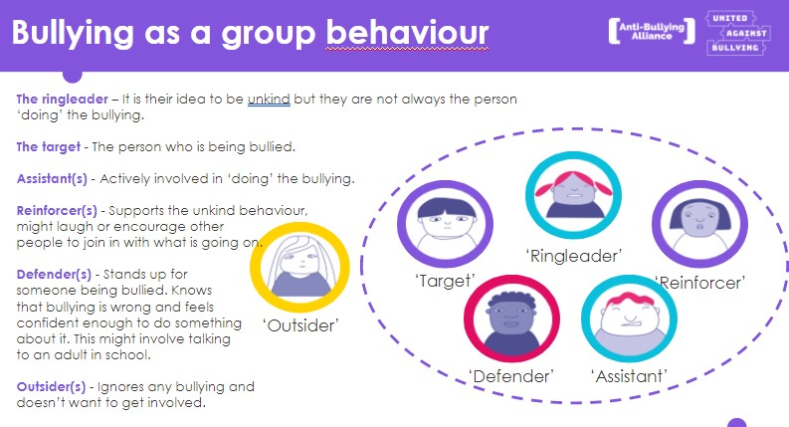

It is essential that children are educated frequently through the curriculum so that the language and definitions used at Excelsior Multi Academy Trust become embedded. Excelsior Multi Academy Trust will use such days as the national, annual ‘Anti-Bullying Week’ and ‘Odd-Socks Day’ to highlight and promote this each year.

Anti-bullying posters will be displayed throughout school, including in classrooms, and should be referenced by staff when challenging and discussing behaviour choices / incidents.

## Monitoring and Reporting

The Headteacher and Deputy Head Teacher regularly monitor the centrally held file of recorded incidents of bullying behaviour, the lunchtime behaviour logs and the record of Green/ Blue Cards. This will be completed by the Behaviour Co-ordinator and reported back to the SLT. Information is fed back to the Governing Body via the Head Teacher report.

## Governors

The Governing Body has a designated governor with responsibility for safeguarding and child protection. The Designated Safeguarding Leader makes an annual report on Safeguarding and child protection to the Governing Body.

Governors regularly review policies and procedures regarding safeguarding and child protection. Governors do not get involved or know details of individual cases.

This policy should be read in conjunction with the school’s Behaviour Policy.

## Policy information

Policy created: March 2025

To be reviewed: As required, and no later than March 2028.